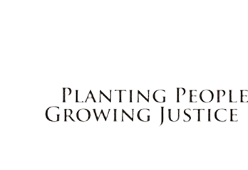
JUSTICE FOR GENERATIONS

Thank you for being part of the PPGJLI team and helping us promote literacy and diverse books!
Here’s a checklist to support you and feel free to contact us with any questions at plantingpeoplegrowingjustice@gmail.com.
Hosting a Virtual Book Drive:
- Pick beginning and ending dates.
- Begin communication prior and include details below.
  - Bookshop
  - Amazon Wish list
  - Amazon Smile list
  - time frame
  - goal of promoting literacy locally
- If you are a resident of the Twin Cities, you can have it mailed to your home to track progress.
- Provide updates to keep the momentum going.
- Mail the books to PO Box 131894, Saint Paul, MN 55113
- For larger donations, drop off at our office

1654 Sherburne Avenue Suite 200 Saint Paul, MN 55104
www.ppgjli.org plantingpeoplegrowingjustice@gmail.com 651-303-6566

